ACG tiene un filtro donde podes inyectar código:
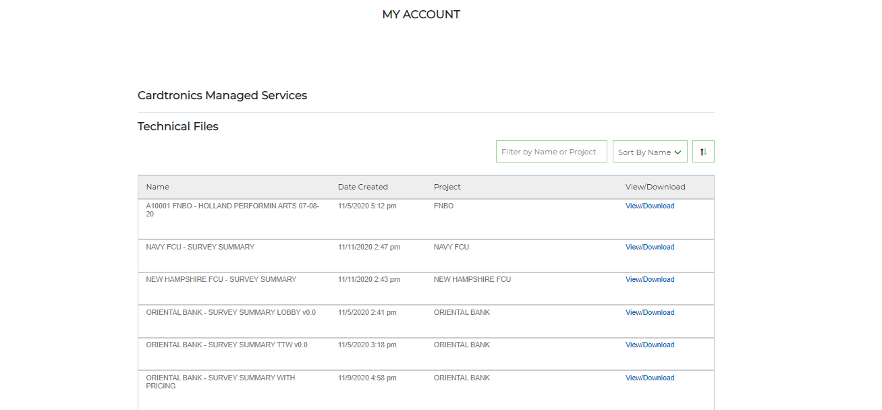

https://4231760-sb2.secure.netsuite.com/c.4231760_SB2/sca-dev-2021-1-0/my_account.ssp?n=2#technicalfiles

Problem: is not showing the theme or anything on mozilla I do not know why. We have to load:
https://sb-acgworld.com.netsuitestaging.com
And user: ilan.daniele@gmail

Also not showing hud context.

https://sb-acgworld.com.netsuitestaging.com/TechnicalFiles.Service.ss
http://sb-acgworld.com.netsuitestaging.com

